Made by: Mayank Patidar Submitted to: Dr. Gaurav Malode sir

Enrollment no. BT20ECE064

Subject: Object oriented programming

------------------------------------------------------------------------------------------------------------------------------------------

**Report**

**INTRODUCTION:**

This is a hospital management user interface for managing, monitoring and controlling the system in a Hospital. This application is developed in java, which mainly focuses on basic operations in a hospital like adding new patient information, and updating new information, assigning the doctor for patient. It features a familiar and well thought-out, an attractive online user interface, combined with strong searching Insertion and reporting capabilities. The Backend of the project is designed with Java, MySQL for database connectivity and front end using HTML, CSS, and Bootstrap. This was my Java mini-project for third year UG.

**TITLE OF THE PROJECT:**

Hospital Management System

**OBJECTIVE OF THE PROJECT:**

This project will help to smoother the process of the hospital activities.

This project will enhance the patients and the hospital to serve more quickly and eﬃciently. This software is developed in order to computerize the activities which take more time, if done manually. If we want any information about patient, we can access it quickly.

This main objective of the system is to computerize the appointment of the patient in the hospital and providing online appointment facility to patient.

**LANGUAGE AND SOFTWARE TOOL USED**

Front End: html, CSS and Bootstrap.

Back End: Java, servlet, Apache Tomcat server

Database: MySQL

Eclipse IDE

**STRUCTURE OF THE PROJECT:**

We have three modules (with separate login and logout feature) in our system:

1. Admin
2. Doctor
3. User

Admin:

* They have control to add the doctor.
* Can check the available number of doctors, users, total appointments and specialists.
* Can add the specialist.
* Can add, edit and check the doctor details.
* Can check the patient details, disease, doctor appointed and status.

Doctor:

* Can see the total number of doctors and number of appointments.
* Can see the appointed patient details.
* Can comment on the appointment taken (only once).
* Can change the password and profile details except email (which can be changed by only admin).

User:

* Can take appointment by filling all the required details along with the date of appointment and the doctor’s name.
* Can view his/her appointments and the status.

**NOTE**: All the CRUD i.e., **Create, Read/Retrieve, Update and Delete** functionalities has been implemented in this project.

**SOURCE CODE:** Refer my GitHub repo - <https://github.com/mayankpatidar275/Hospital-management-system>

**SOFTWARE SYSTEM ATTRIBUTES**

**Usability:** Software can be used again and again without distortion.

**Availability:** The system shall be available all the time.

**Correctness:** Bug free software which fulfills the correct need/requirements of the client.

**Maintainability:** The ability to maintain, modify information and update fix problems of the system.

**Accessibility:** Administrator and many other users can access the system but the access level is controlled for each user according to their work scope.

**SCREENSHOTS OF THE WEB APPLICATION SHOWING ALL THE FUNCTIONALITIES:**

Home page:

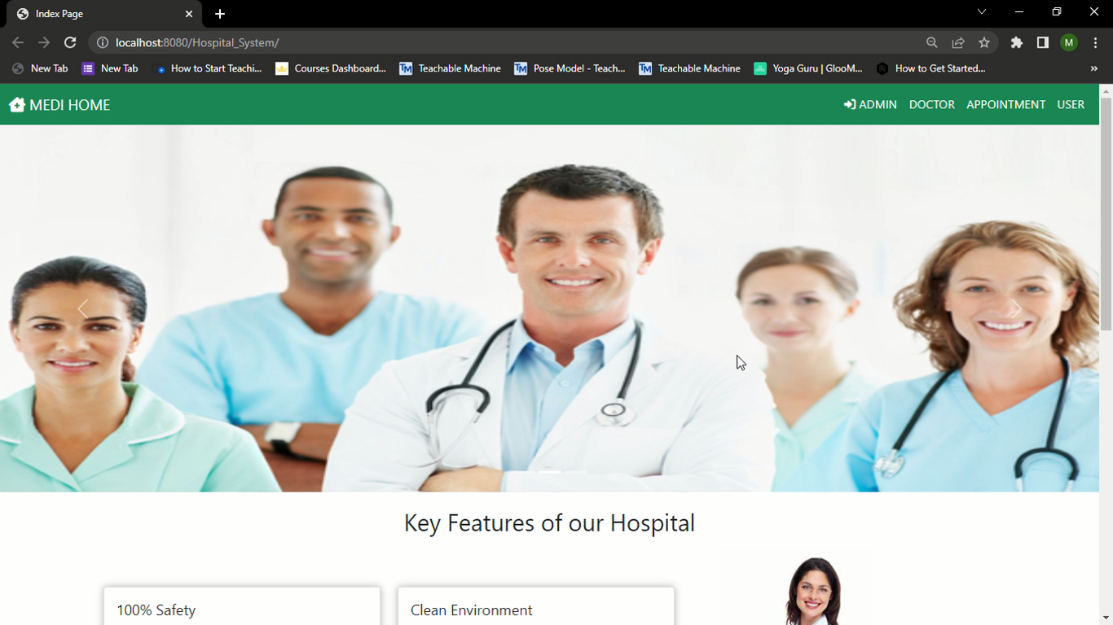

Admin login page and Dashboard page:**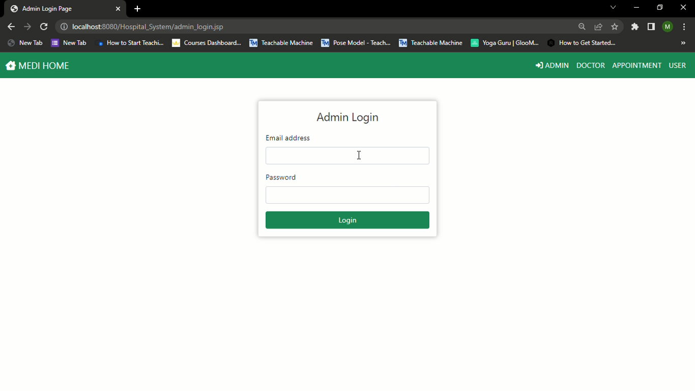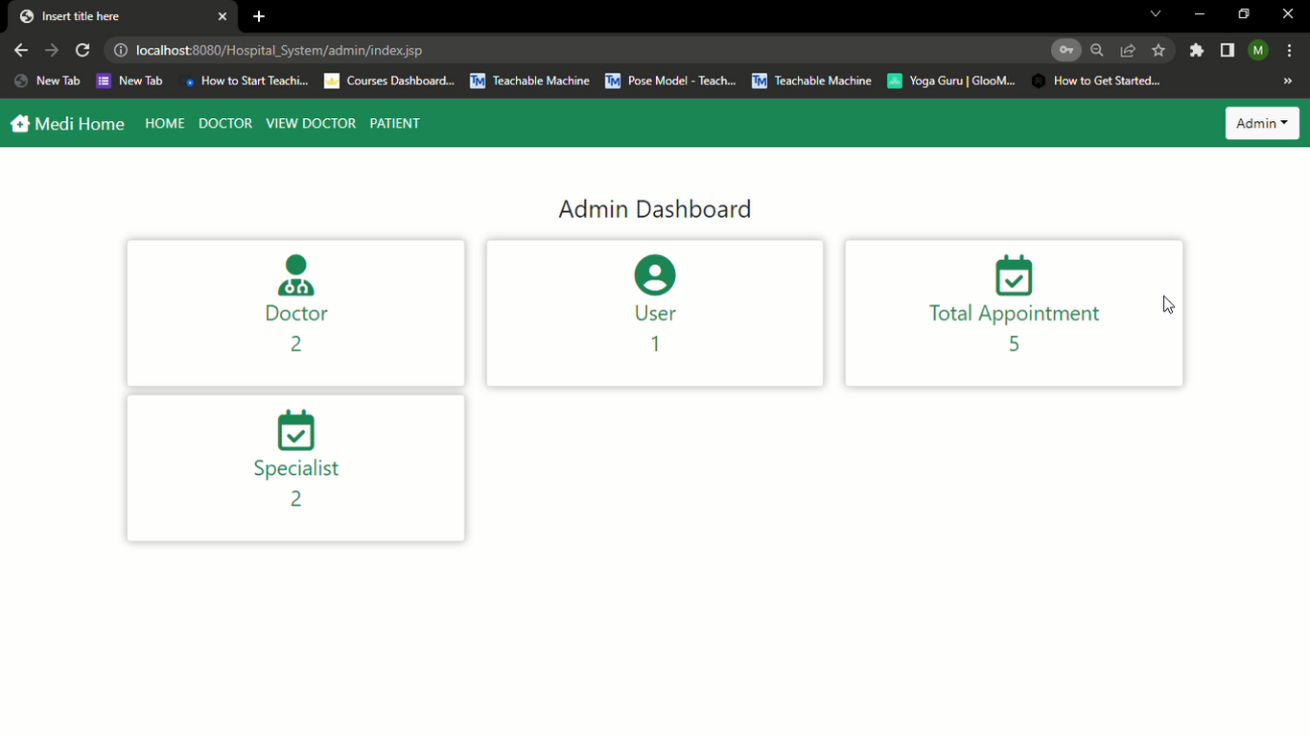Specialist adding page:**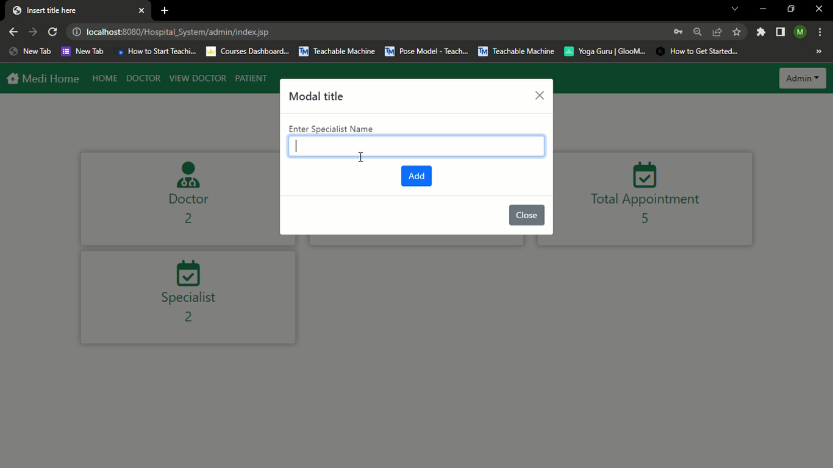

**Adding doctor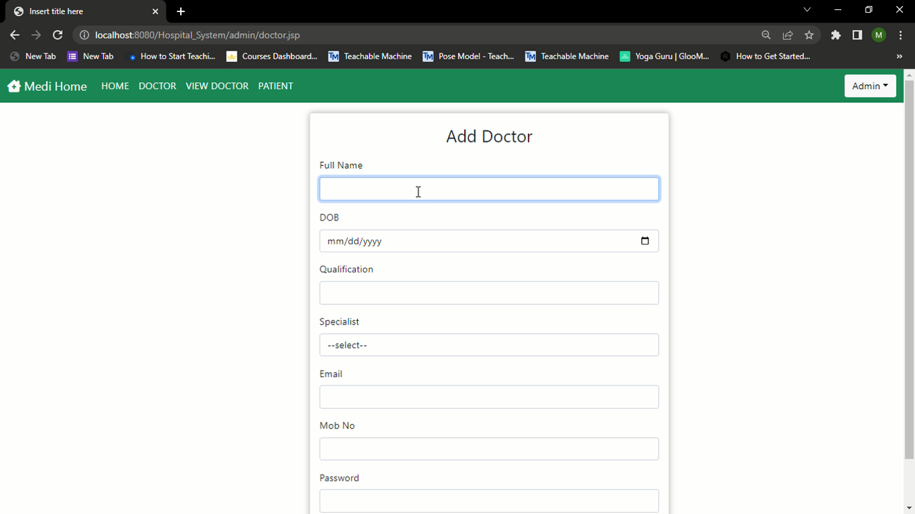Admin can see all the doctors:**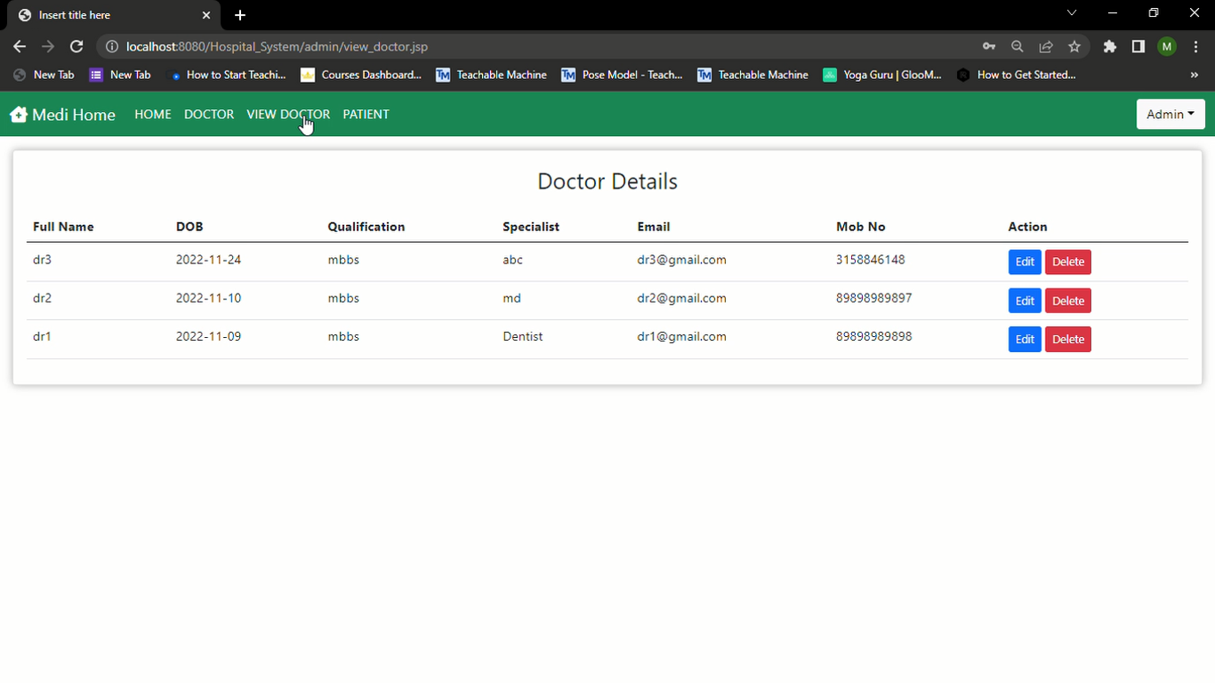

**Admin can edit doctor details: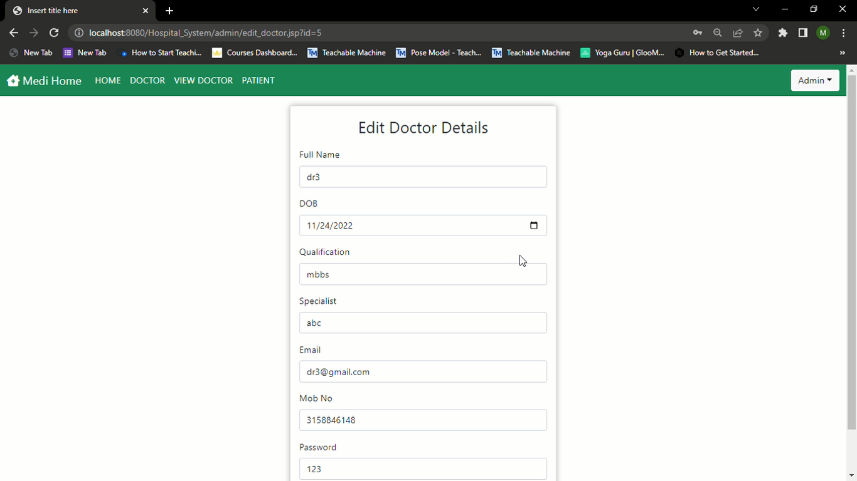Patient details**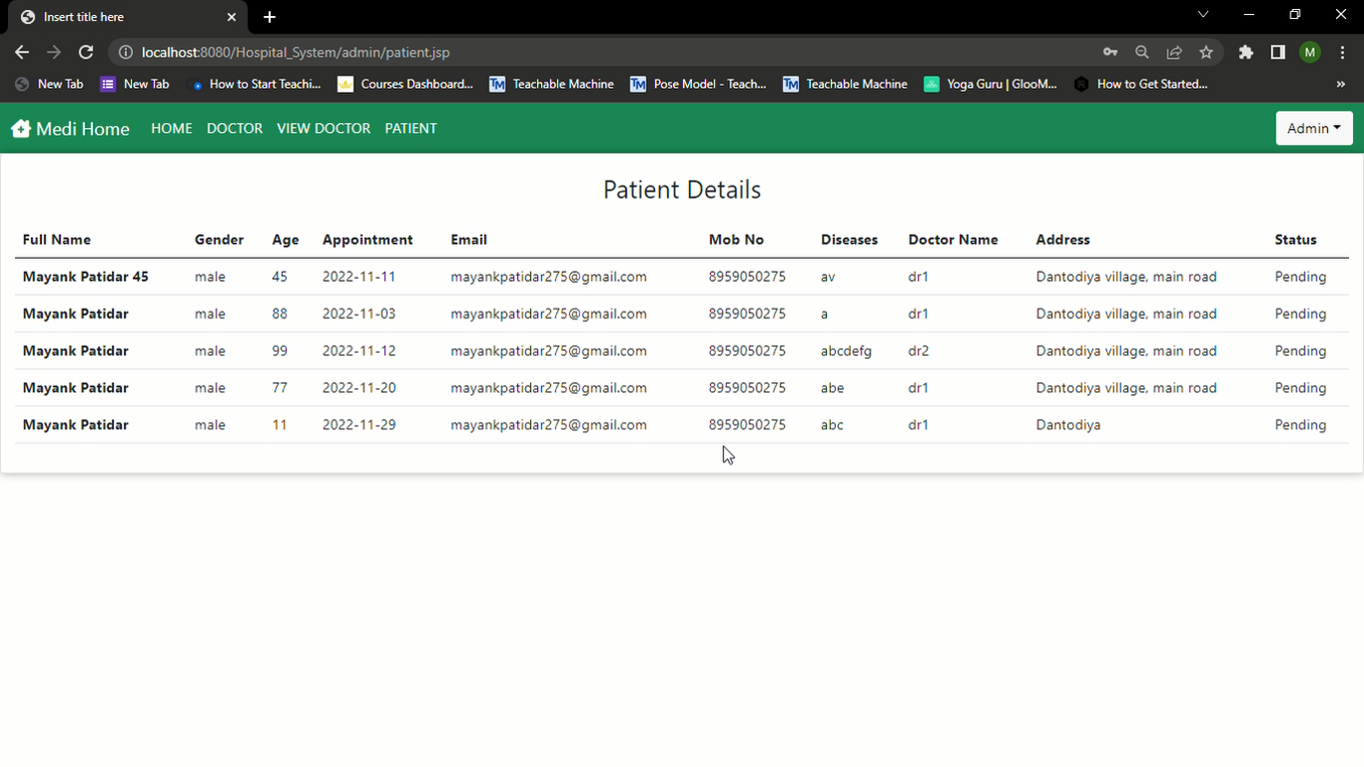

**Doctor login page: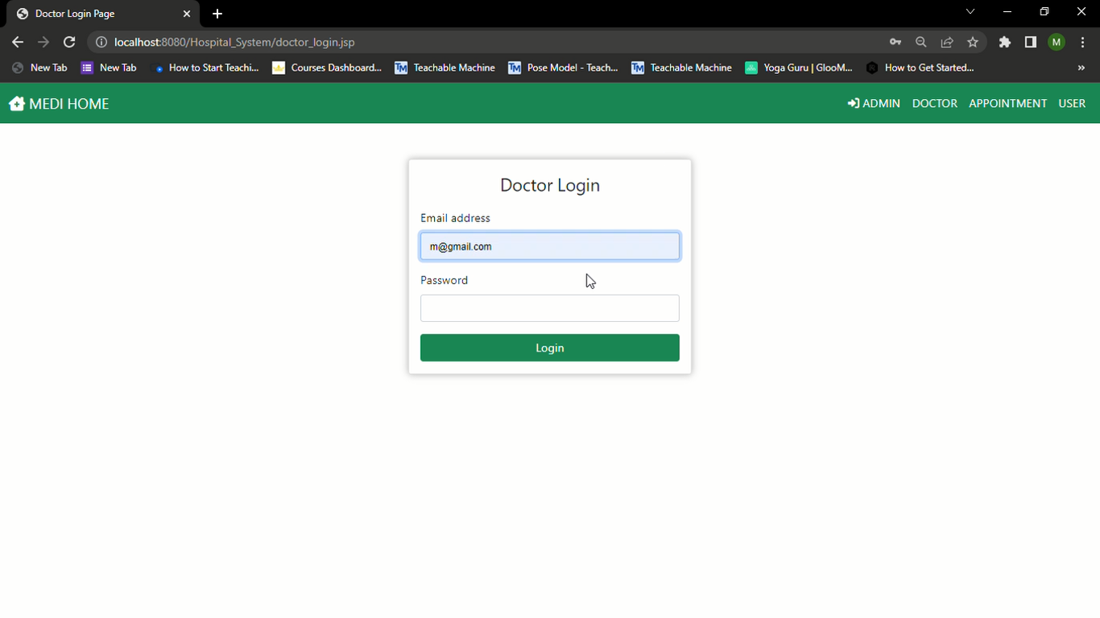Doctor Dahboard page**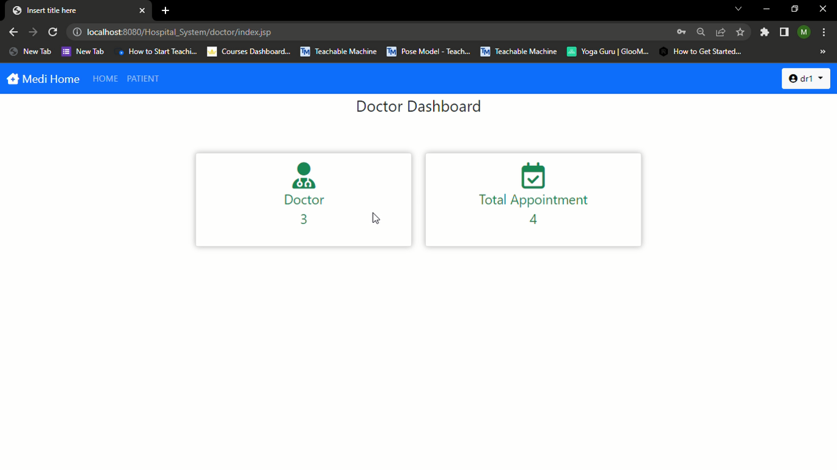

**Patient details page: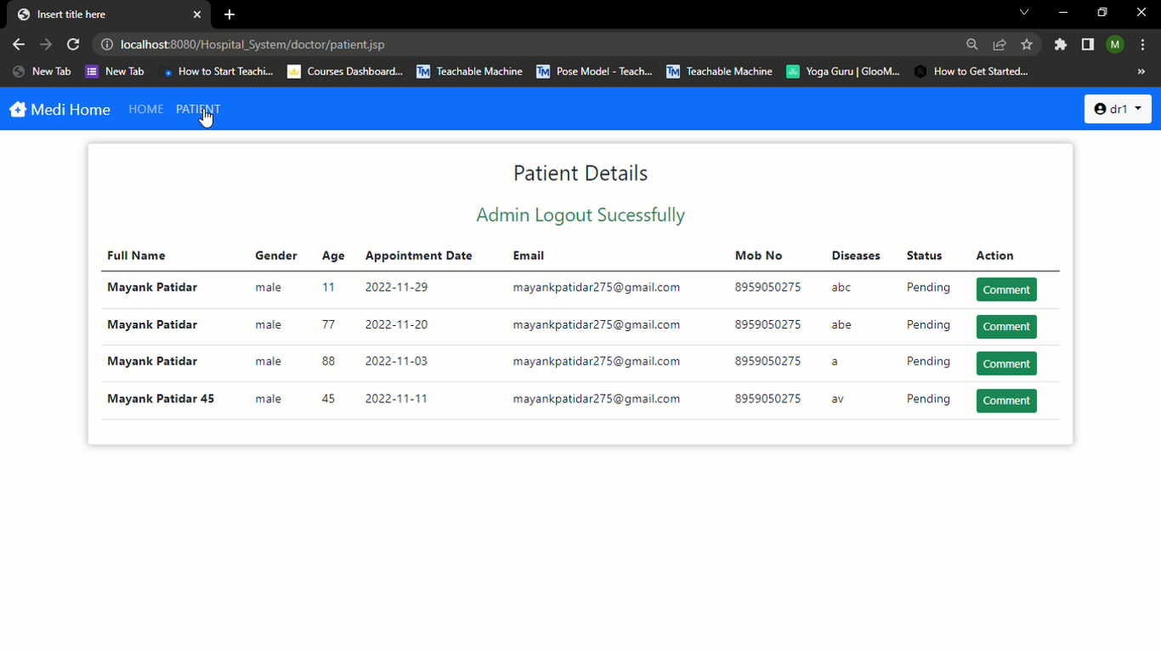Doctor can comment on the patient:**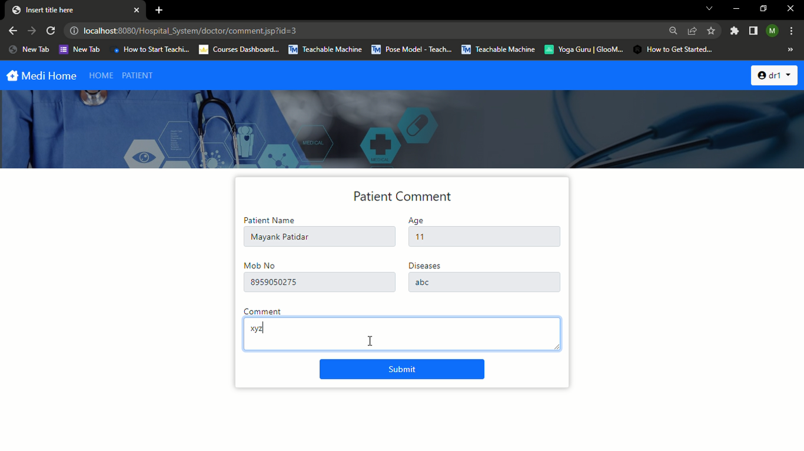

**Patient details gets updated: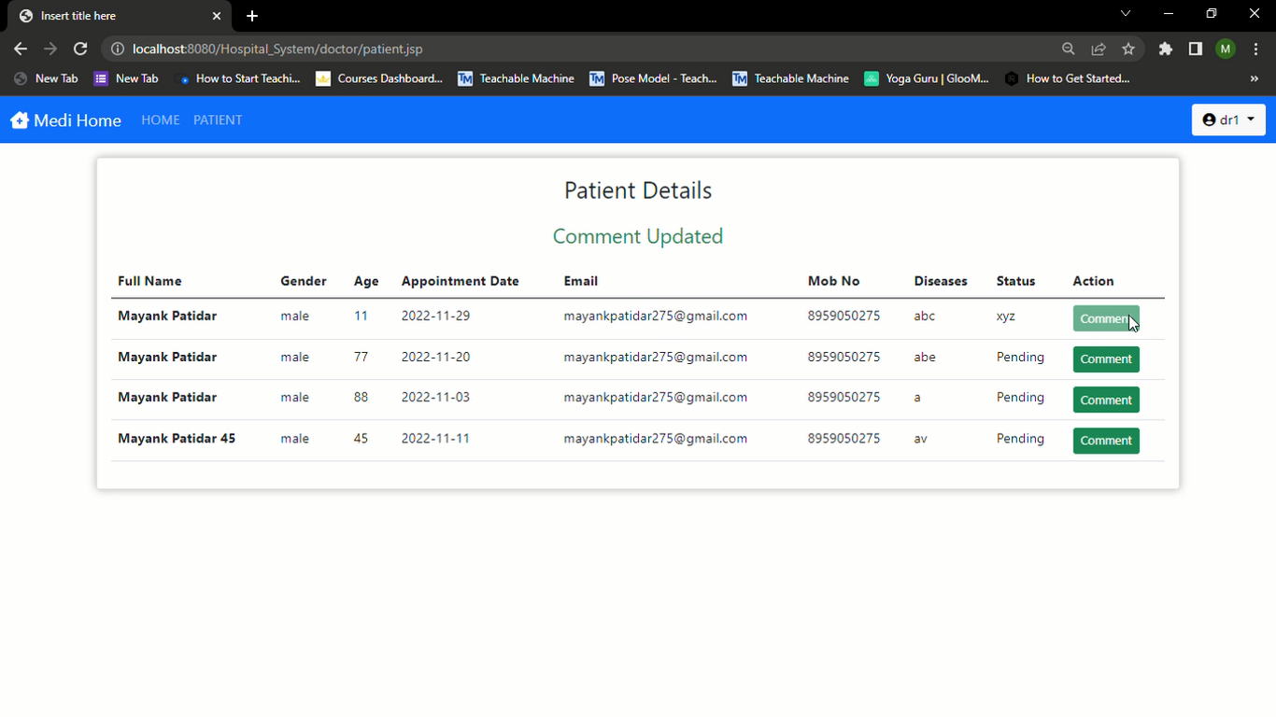Doctor can change his Password and edit his profile:**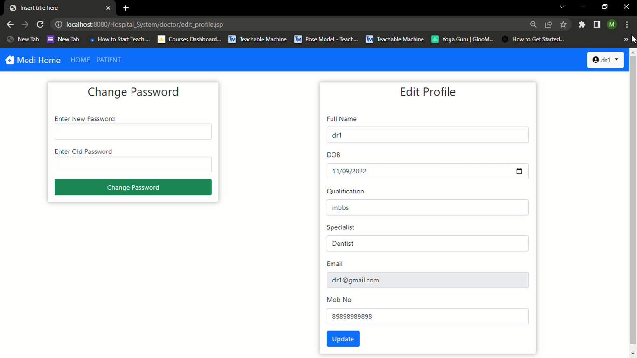

**User login and then take appointment: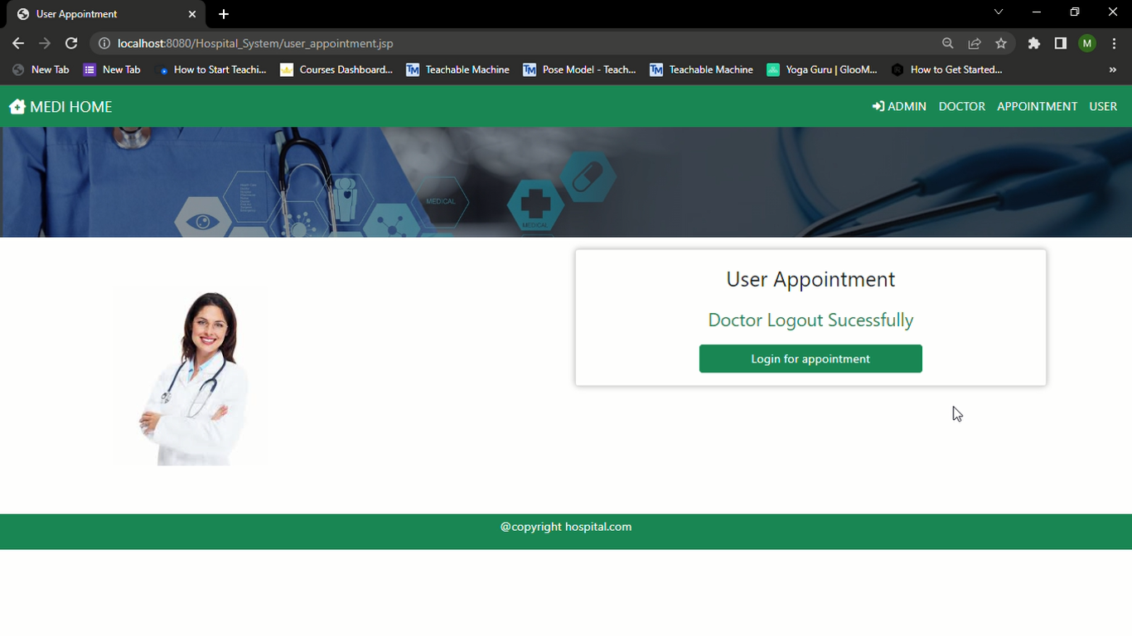User login page:**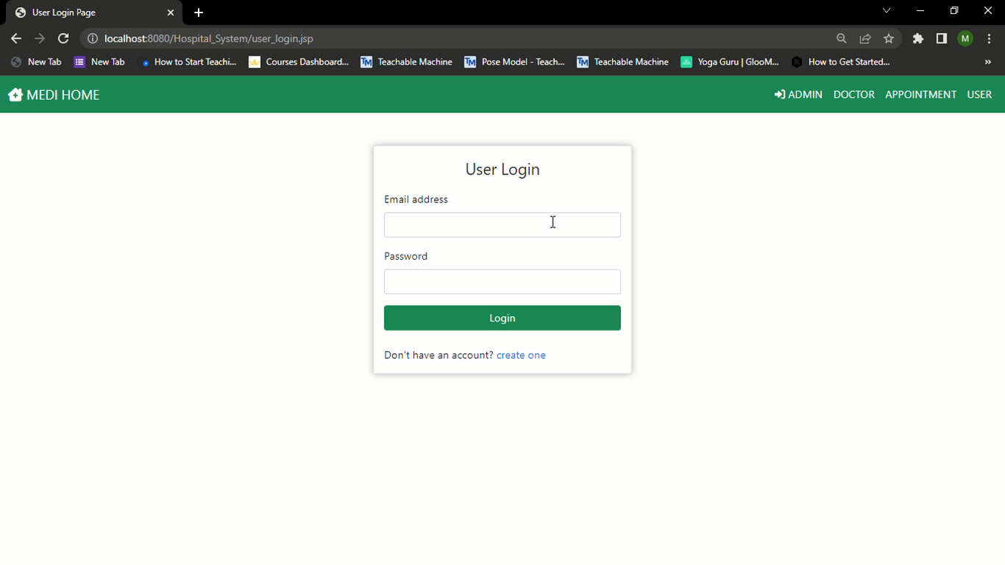

**User dashboard page: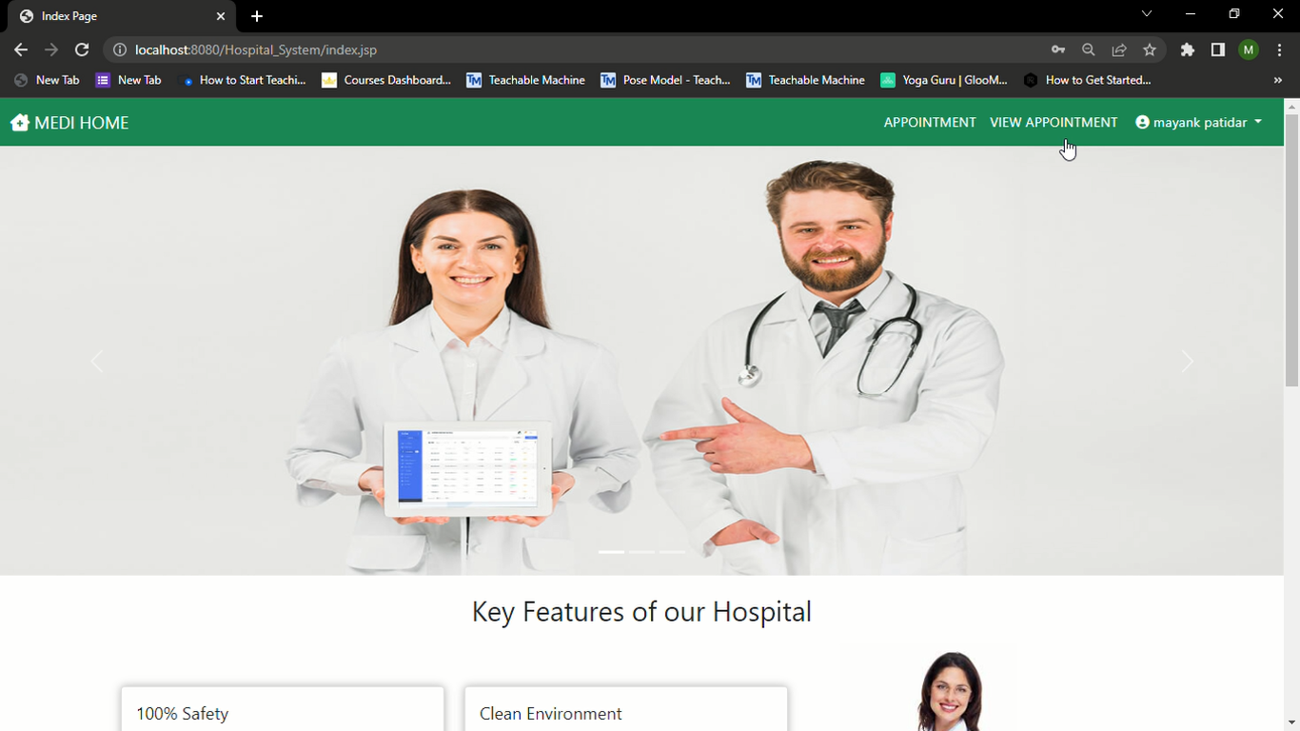User appointment befor:**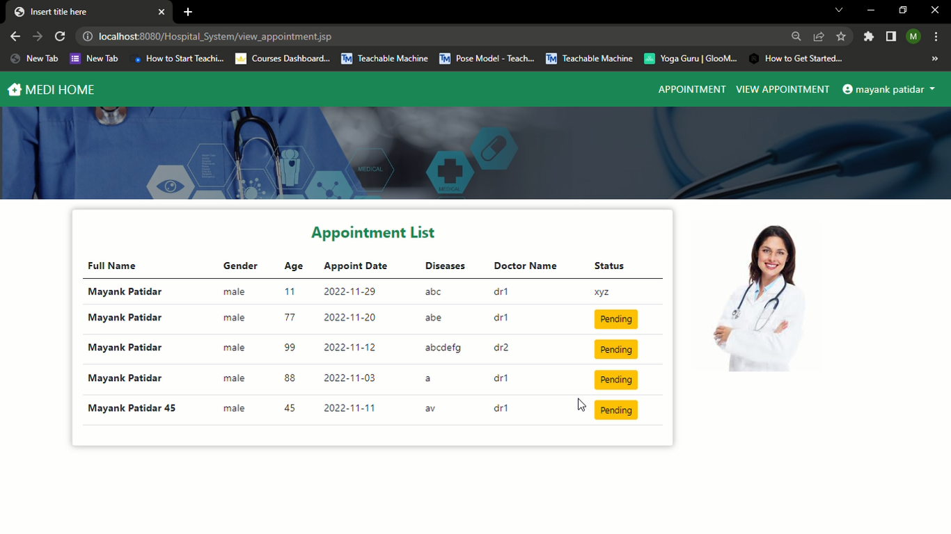

**User taking appointment: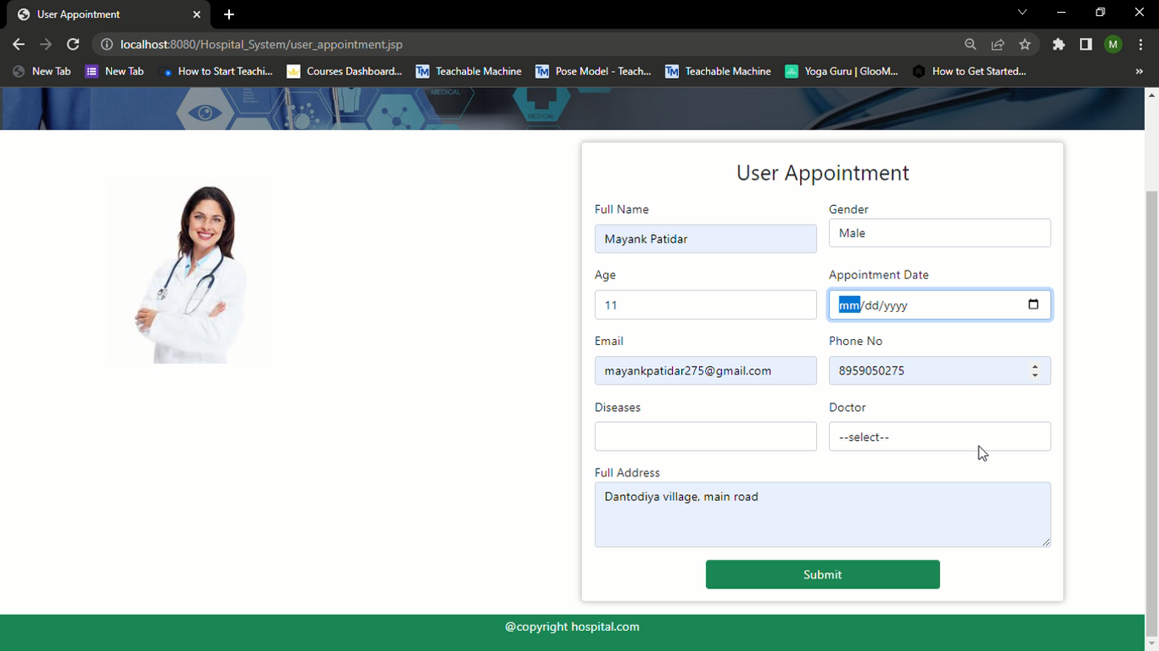Appoitment taken successfully:** 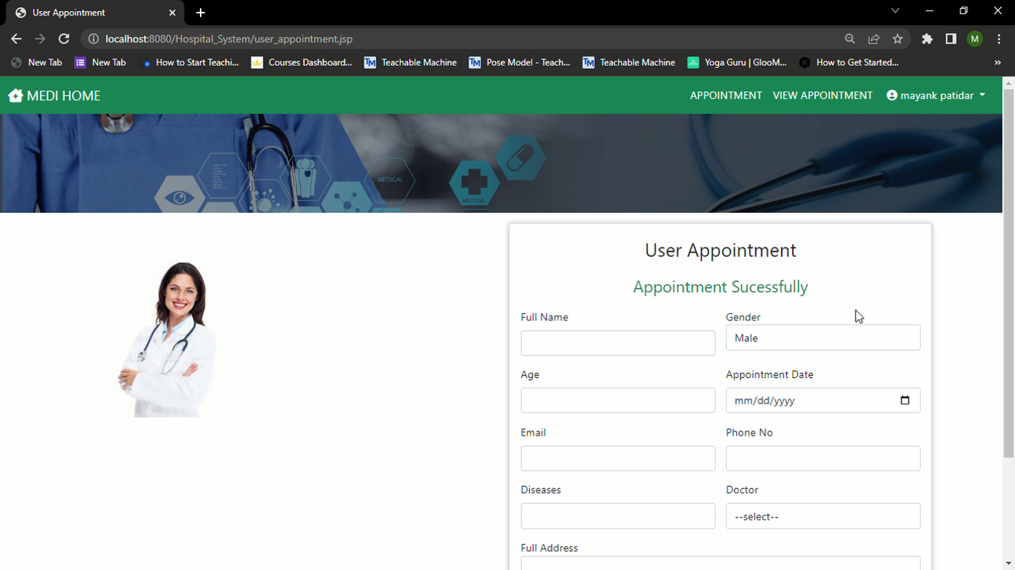

**Appointment list after: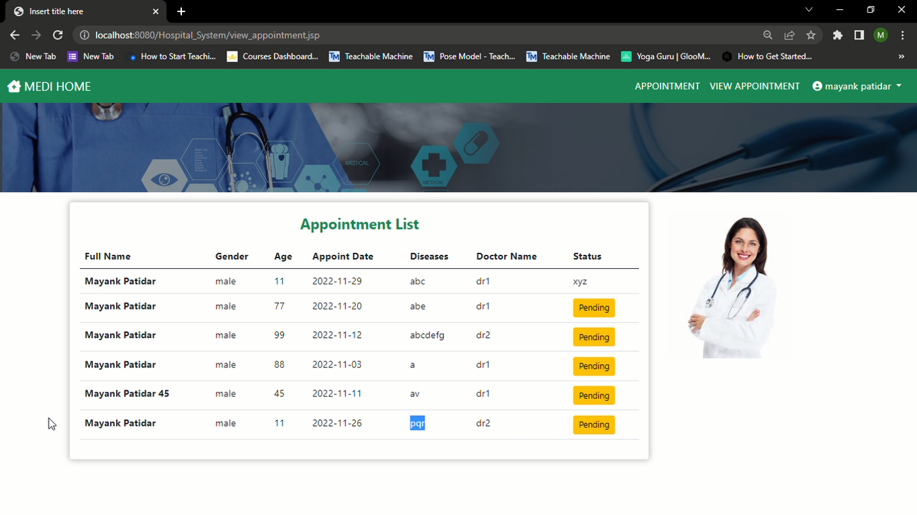MySql Workbench, showing all the data:**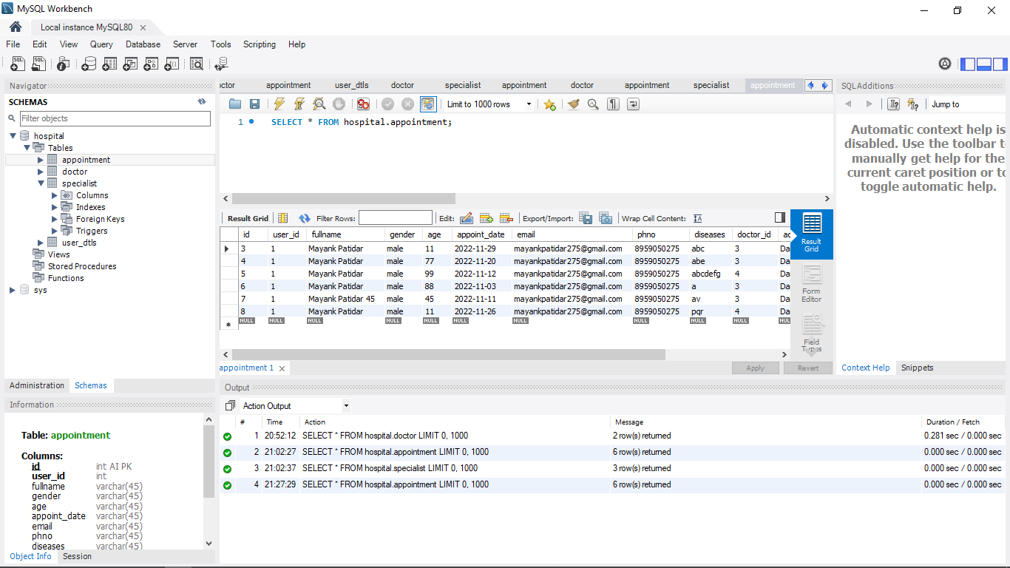

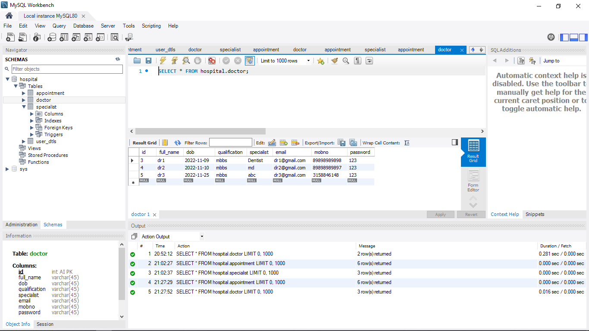

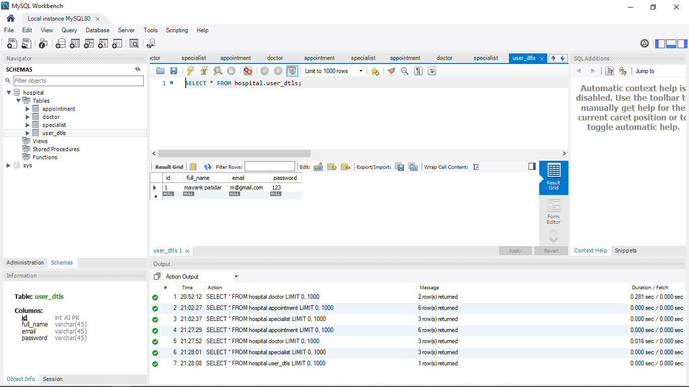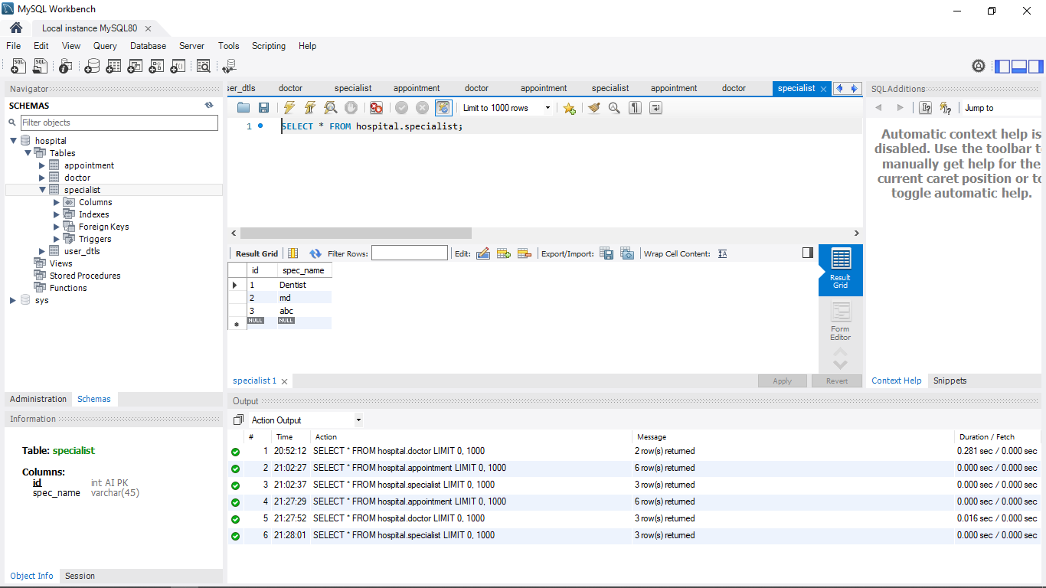

**Eclipse window showing the way code is structured:**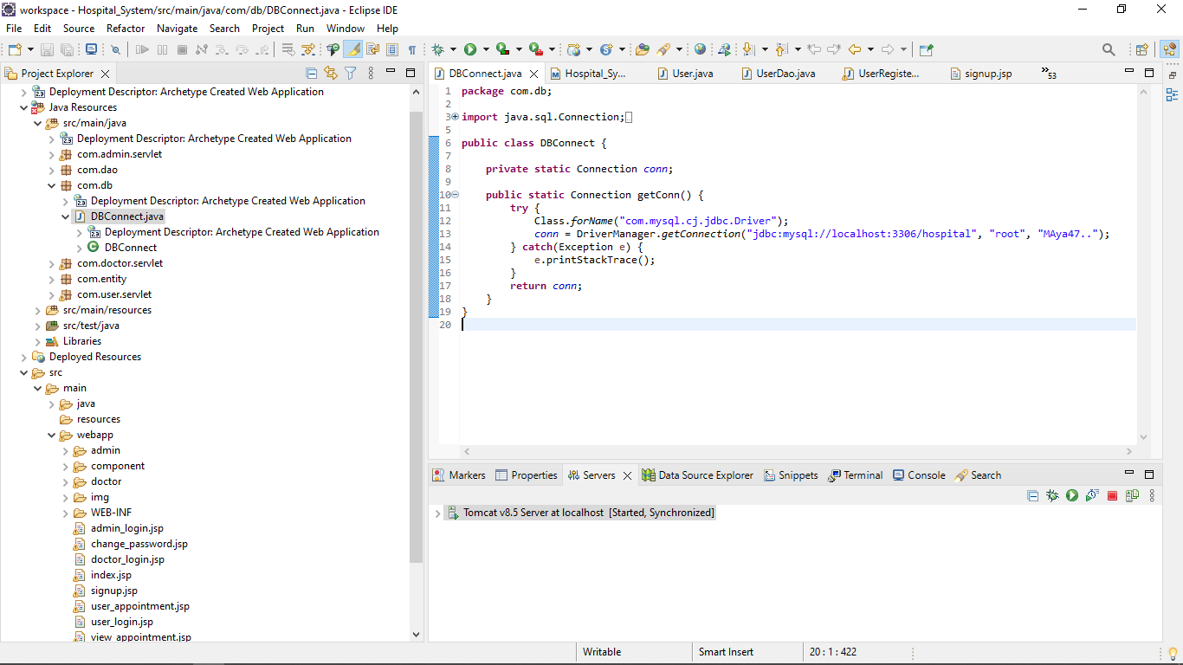

**…Thank You…**